**Robotics I – Project 3 Fall 2020**

**Navigate to a point**

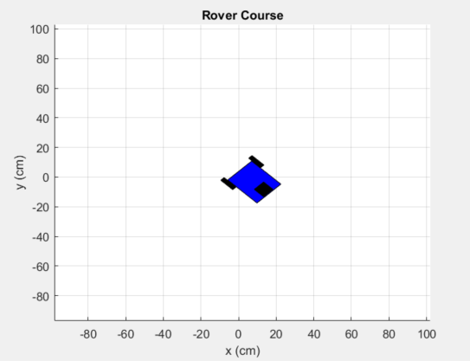

**Project Assignment: Develop code to implement the kinematics of our mobile robot and navigate that robot to a pre-defined final pose:**

1. **Add code to the TopLevel file to define a function which navigates to the final pose point, using a pre-defined program like I implemented as an example**
2. **In the propagatePose function propagate the pose of the vehicle by doing the translation first then the rotation, this is a fair assumption if the timestep is small enough.**
3. **In the kinematics_diff_drive function fill in the equations for the kinematics to give velocity, v, and angular velocity w.**

**Notes:**

**Search for the text “TODO.” This will show you where you are to add the code for the modifications.**